**HyMar Subtask 1 – University of Ottawa’s report**

Thanh Son Nguyen

1. **Mathematical model**
   1. **Governing equations for HM behaviour**

The governing equations of the University of Ottawa’s model are derived from mass and momentum conservation principles. They are as follows:

(1)

(2)

In the above equations, ** is porosity, *f* is the porefluid density, ***u*** is the porefluid volume flux and ****** is the total stress tensor. Quasi-static conditions were assumed, therefore there is no inertial terms in the momentum conservation equation.

* 1. **Constitutive relations**
     1. Stress-strain-damage, strain localization

Biot’s effective stress principle was adopted, then the effective stress ***’*** is related to the total stress ****** according to:

(3)

where ** is Biot’s coefficient, *p* is porefluid pressure, and ***I*** is the identity tensor.

Using the elastoplastic framework to simulate the mechanical behaviour of the porous medium, effective stress is related to strain according to:

(4)

where ***D*** is the elastic stiffness tensor, ****** is the total strain tensor, and ******p is the plastic strain tensor.

Transversely isotropic elaticity

OPA is assumed to be transversely isotropic, with two principal directions parallel to the bedding orientation, and the third one being perpendicular to bedding. There are five (5) elastic constant for the elastic stiffness tensor :

* Young's modulus and Poisson’s ratio in the bedding plane, Ep and p
* Young's modulus and Poisson’s ratio in the z direction (perpendicular to bedding), Ez and pz:
* Shear modulus in the z-direction Gzp

Then, the elastic compliance tensor in equation (4) could be explicitly written as:

(5)

Plasticity for transversely isotropic material

We use the original Hoek- Brown’s criterion (Reference) as a yield function to initiate plastic strain:

(6)

where and are respectively the major and minor principal effective stresses, is a measure of uniaxial strength and *m* is a Hoek and Brown parameter. The m parameter represents the friction component while is the cohesion component.

The model assumes that plastic deformation starts at the crack initiation threshold , followed by strain hardening until the peak uniaxial strength , followed by strain softening to the residual strength .

The Hoek-Brown criterion in equation (6) was generalized to account for the intermediate principal stress, by adopting the form of the yield function *F* used in the finite element software COMSOL Multiphysics ®:

(7)

where is the second invariant of the deviatoric stress tensor and is the Lode angle.

In order to reduce excessive dilation, we used a non-associated flow rule, by defining a potential function which has the same form as the yield function in equation (8) but with a value *m’* which is a fraction of *m* to replace the latter in equation (8).

Material anisotropy in plasticity is taken into account by expressing the compressive and tensile strength as a function of an isotropy factor derived from the microstructure tensor approach by Pietruszcak and Mroz( 2001). In that approach, a microstructure tensor indicative of material frabric *aij* is defined. For a transversely isotropic material such as OPA, the principal directions of *aij* correspond to two directions in the bedding plane and one direction perpendicular to the bedding plane. The projection of the effective stress tensor in each principal direction of the microstructure results in three traction components that defines a loading vector , the loading direction is then the unit vector . An anisotropy factor is then defined as the projection of *aij* on the loading direction:

(8)

For a transversely isotropic material, it could be shown that (Pietruszcak and Mroz, 2001):

(9)

where *l3* is the loading direction perpendicular to bedding.

By analogy to equation (10), the peak compressive and tensile strength are expressed as:

(11)

(12)

(13)

The constants of equations (11) -13) are determined by best-fitting the experimental data as shown in Figure 1.

Figure 1 Variations of peak compressive and tensile strength and m parameter with loading orientation

Localization of deformation

As previously indicated, our model assumes that plastic deformation starts at the crack initiation threshold , followed by strain hardening until the peak uniaxial strength , followed by strain softening to the residual strength . The effective plastic strain *p* commonly used as the hardening parameter is defined as:

(14)

where tensorial notation and summation convention is used.

In order to improve the mesh dependency problem associated with predicting localization of deformation near and after the peak strength, we used a nonlocal plasticity approach, where instead of using the punctual effective plastic stain as defined in equation (14), we used a volume average around the same point. There are many methods to determine that volume average (Ref.), here we define a nonlocal plastic strain using the implicit gradient method by solving the Helmholtz equation (e.g. Engelen et al. 2003):

(15)

where is the nonlocal plastic strain and *d* (m) is an indicator of the dimension of the volume of influence.

Then, we assume a hardening-softening function as follows:

when < (16-a)

when ≥ (16-b)

where A and are calibrated parameters.

* + 1. Porefluid flow

Fluid flow is governed by Darcy’s law:

(17)

where ***u*** is the pore fluid flux (m3/m2), ***k*** is the permeability tensor, ** is porefluid viscosity, and p is pore fluid pressure.

1. **Numerical model**
   1. Geometry, boundary and initial conditions

The geometry and boundary conditions and initial conditions for the CU tests are shown in Figure 2.

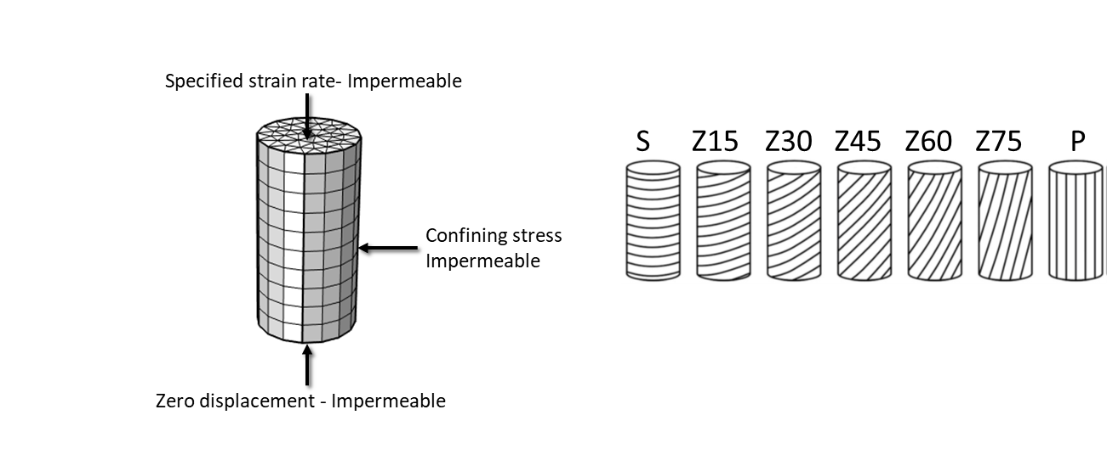

Figure 2 Finite element mesh and boundary conditions for CU tests –Initial pore pressure and confining stress are defined in table 1. Modelling was performed for different bedding orientation, with sample names as illustrated

**Table 1 – Initial conditions in CU test simulations**

|  |  |  |
| --- | --- | --- |
| **Sample- effective confining pressure (MPa)** | **Total confining stress (MPa)** | **Initial pore pressure (MPa)** |
| P-4 | 12.5 | 2.5 |
| P-10 | 6.5 | 2.5 |
| S-10 | 13.3 | 3.3 |
| Z45-10 | 12.8 | 2.8 |
| Z60-10 | 12.5 | 2.5 |
| Z60-4 | 7.5 | 2.5 |

* 1. Model input, material properties

Model input is shown in table 2.

**Table 2. Input parameters for simulations of CU tests**

|  |  |  |
| --- | --- | --- |
| **Input parameter** | **Value** | **Source** |
| *Elastic constants* |  | Calibrated from UCS tests |
| Ep [MPa] | 2300 |
| p | 0.24 |
| Ez [MPa] | 1000 |
| pz | 0.24 |
| Gpz[MPa] | 200 |
| *Peak compressive, tensile strength*  *m, m’* | Equations (11), (12),(13)  And Figure 1 | Calibrated from UCS and BTS tests |
| *Permeability (m2)* |  | Gens et al. |
| Along bedding | 5.10-20 |
| Normal to bedding | 10-20 |
| Porosity (-) |  |  |
| Water compressibility (Pa-1) |  |  |
|  |  |  |
| *Biot’s coefficient* | 0.7 | Gens et al. |
| *Characteristic localization length (m)* | 0.001 | Assumed based on grain size |

1. Modelling results/comparison with experimental data (see Excel template)
   1. UCS, BTS for different orientation

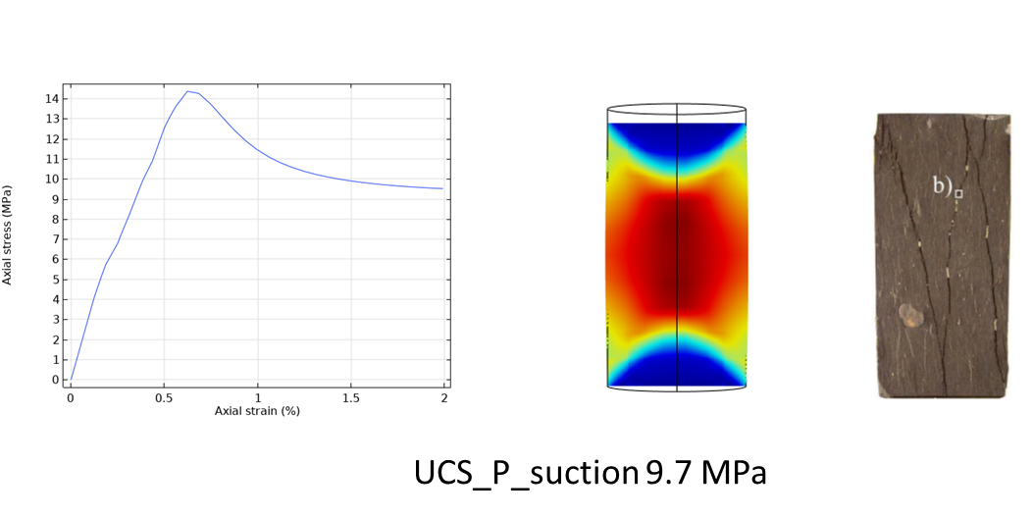

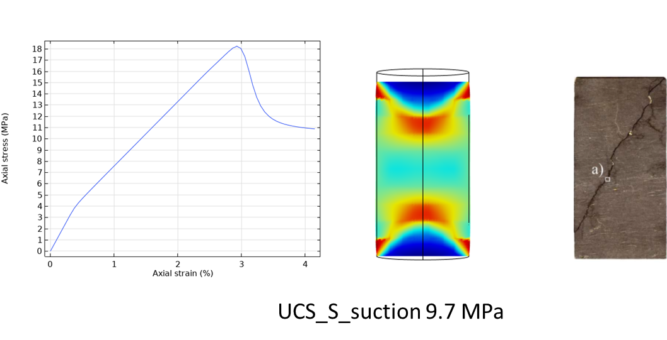

Figure 2. Typical simulation results for UCS test - *Stress–strain evolution and localized plastic zones are shown and compared to observed damage patterns*

Typical simulation results for the UCS tests are presented in Figure 2. The stress –strain evolution is shown, and the calculated plastic strain localization zones are compared with the observed damage patterns. *Discussion will be expanded.*

Peak UCS for different bedding angle is shown in Figure 3. *Discussion will be expanded.*

Figure 3 Calculated UCS compared to measurements for 9.7 MPa suction

* 1. CU results for P, S, Z45 at different confining stress

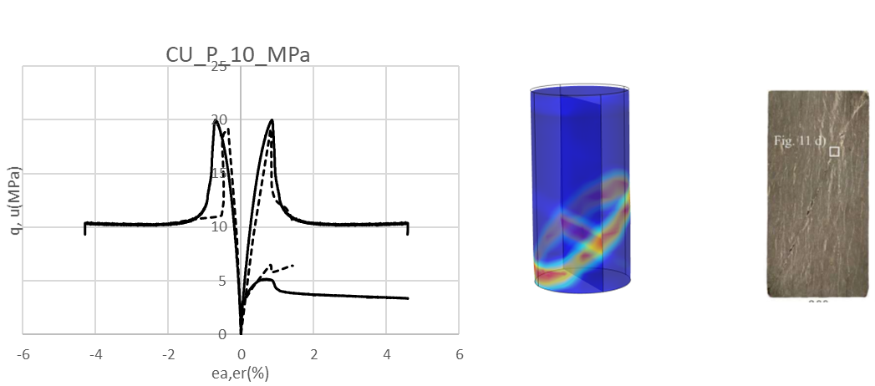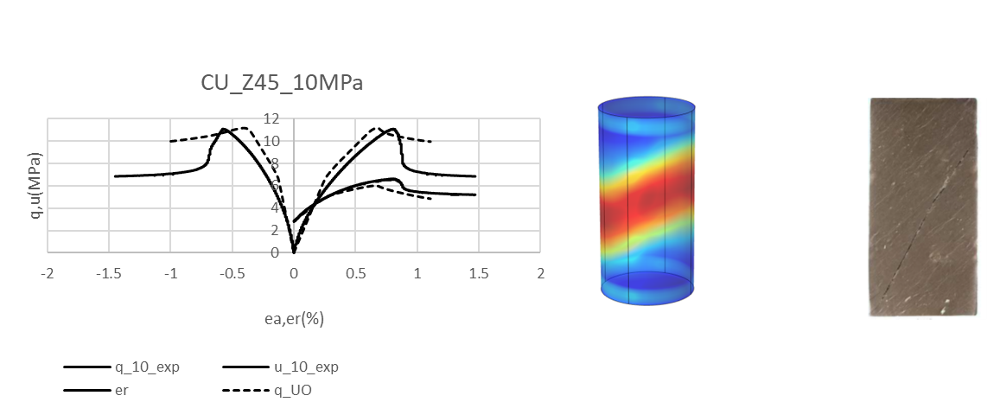

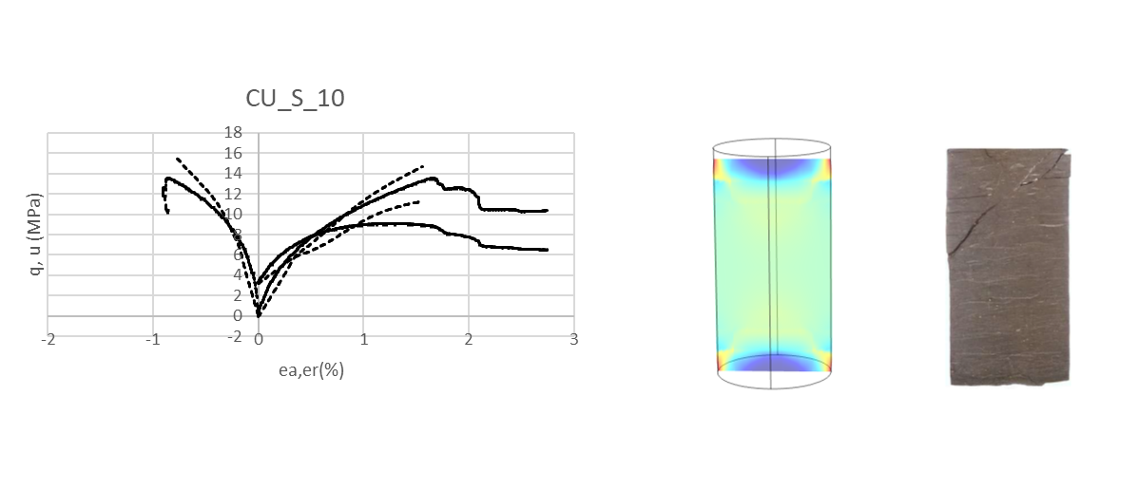

Figure 2. Effects of loading orientation for CU tests at 10 MPa effective confining stress - *Solid lines are experimental results, dotted lines are modelling results. Plastic shear zones are shown and compared to damage features observed after the tests.*

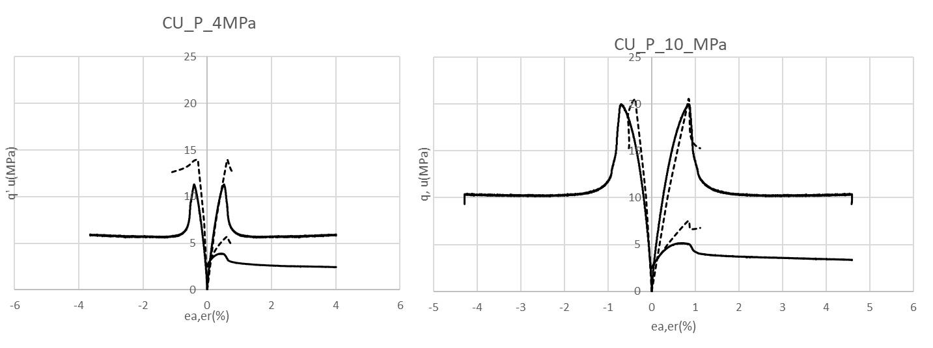

Figure 3 . Effects of confining stress for CU test of the P-sample

More results and discussion will be given.

* 1. Proposal of criterion for dilatancy

Dilatancy starts at the onset of plasticity, where dilation due to plastic deformation starts. In our model, this would start when the state of stress first reach the yield criterion in equation (7), with c=ci :

(16)

From there, we propose to use the effective plastic strain as a measure of damage that induces an increase in permeability. An expression of the form as proposed by BGR could be adopted:

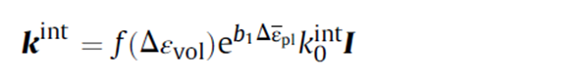[17]

Incorporating this into a model for gas flow could be promising to simulate the increase in flow in the dilatancy regime.

**References**

*To be included*